**LEARN SUNNAH**

A Project Report submitted to the

Department of Computer Science and Engineering,

Bangabandhu Sheikh Mujibur Rahman Science and Technology University

in partial fulfillment of the requirements for the degree of

B.Sc. in Computer Science and Engineering

By

Md. Juwel Mallick

ID: 18CSE018

Session: 2018 - 2019

Supervised by

Dr. Mrinal Kanti Baowaly

Associate Professor



DEPARTMENT OF COMPUTER SCIENCE AND ENGINEERING

BANGABANDHU SHEIKH MUJIBUR RAHMAN SCIENCE AND TECHNOLOGY UNIVERSITY

JULY 2023

# **Abstract**

"Learn Sunnah" is a comprehensive social e-learning platform designed to facilitate users in leading a more meaningful life by gaining insights into the teachings and behaviors of Sunnah. The platform offers an interactive and user-friendly experience to explore Islamic knowledge through various learning methods. Users can access a free library of Sunnah-related resources, participate in a dynamic Question & Answer section, and engage in community discussions.

Through a combination of frontend technologies such as HTML, CSS, Tailwind CSS, and JavaScript, and backend powered by Django, the platform ensures a seamless and secure user experience. "Learn Sunnah" stands as a valuable resource for individuals seeking to deepen their understanding of Sunnah teachings and practices, fostering a community-driven platform for knowledge sharing and spiritual growth.

# **Declaration**

The research work entitled “**Learn Sunnah**” has been carried out in the Department of

Computer Science and Engineering, Bangabandhu Sheikh Mujibur Rahman Science and

Technology University is original and conforms to the regulations of this University.

I understand the University’s policy on plagiarism and declare that no part of this project has

been copied from other sources or been previously submitted elsewhere for the award of any

degree or diploma.

**(Supervisor)**

……………………………………………………………

**Dr. Mrinal Kanti Baowaly**

Associate Professor

Department of Computer Science & Engineering

BSMRSTU

**(Candidate)**

……………………………………………………………

Md. Juwel Mallick

ID:18CSE018

3rd Year 2nd Semester.

Department of Computer Science & Engineering

# **Acknowledgment**

I would like to express my sincere gratitude to my supervisor Dr. Mrinal Kanti Baowly for providing invaluable guidance, comments, and suggestions throughout the course of the project.

I perceive this as a good opportunity for my career development.

I am very grateful to the great creator for completing the project.

Md. Juwel Mallick

18CSE018

July, 2023

Table Of Contents

**Abstract** 2

**Declaration** 3

**Acknowledgment** 4

**Introduction** 7

1.1 Introduction 7

1.2 Motivation & Aims 7

1.2.1 Motivation: 7

1.2.2 Aims: 7

1.3 Objectives 8

1.4 Scope of the Project 9

1.5 Modules 9

Requirement Specification 11

2.1 Frontend and Backend Requirements 11

2.2 User Authentication and Profiles 11

2.3 Content Management Modules 12

2.4 User Engagement and Community Features 12

2.5 Security, Performance, and Scalability 12

Frontend Features 13

3.1 Frontend Design and Functionality 13

3.2 Content Modules Interface 13

3.2.1 Book Library Module Interface 13

3.2.2 Question & Answer Module Interface 14

3.3 User Interaction and Navigation 16

3.4 Interactive Elements 17

3.5 User Experience and Optimization 17

Backend Features 18

4.1 Data Management and Database Design 18

4.2 User Authentication and Authorization 19

4.3 Content Management System (CMS) 19

4.4 Backend API Development, Integration, and Error Handling 20

Project Evaluation and Future Plans 20

5.1 Performance Evaluation and User Feedback 20

5.2 Achievements and Challenges 21

5.3 Future Growth and Community Engagement 21

5.4 Conclusion 21

LIST OF FIGURES

Figure 2.1 TailwindCSS With Django 11

Figure 2.2 JavaScript 11

Figure 3.1: Learn Sunnah home page 13

Figure 3.2: Sunnah Library home page 14

Figure 3.3: Book details page 14

Figure 3.4: Question view with comments 15

Figure 3.5: Profile with dashboard 16

Figure 3.6: Question post form 17

Figure 4.1: Django Admin panel 19

Figure 4.2: Question manage in the backend 20

**Chapter 1**

# **Introduction**

## Introduction

The "Learn Sunnah" project is a social e-learning platform designed to help users lead a proper life by learning the teachings and behaviors of Sunnah. The platform offers an interactive learning experience through a vast collection of PDF books and a question-and-answer section. Users can access diverse Sunnah resources, interact with the community, and gain expert guidance to implement Sunnah in their daily lives.

## Motivation & Aims

The motivation and aims of the "Learn Sunnah" project are to provide users with an interactive platform to learn and implement Sunnah teachings, leading to a more meaningful life guided by Islamic principles.

### 1.2.1 Motivation:

The primary motivation behind the "Learn Sunnah" project is to provide an interactive platform that empowers users to learn and implement Sunnah teachings in their daily lives. Sunnah, the practices and teachings of the Prophet Muhammad (peace be upon him), holds immense significance in Islam and serves as a guiding light for Muslims seeking a more meaningful and purposeful life. However, access to authentic and reliable sources of Sunnah knowledge can be challenging, especially for those with limited resources or busy schedules. The "Learn Sunnah" project aims to bridge this gap by creating a social e-learning platform that offers accessible and comprehensive Sunnah education to users worldwide.

### 1.2.2 Aims:

The main aims of the "Learn Sunnah" project are as follows:

**Interactive Platform**: The project seeks to establish an interactive and user-friendly platform that allows individuals to engage actively with Sunnah teachings. By integrating various multimedia elements, such as text, videos, and images, users can experience a dynamic learning environment that caters to different learning styles.

**Islamic Behavior and Activities:** The project focuses on promoting Islamic behavior and activities inspired by Sunnah. By presenting practical examples and real-life scenarios, users can apply Sunnah teachings to their daily interactions, leading to a more ethical and compassionate society.

**Free Sunnah Resources**: One of the primary aims is to curate and provide a diverse and extensive library of Sunnah-related resources. This collection includes PDF books, articles, and other informative content, all available for users free of charge. By offering a vast repository of knowledge, the project aims to promote continuous learning and exploration of Sunnah principles.

**Q&A Interaction:** The "Learn Sunnah" platform incorporates a question and answer section where users can seek expert guidance and clarification on various topics related to Sunnah. By fostering an environment of knowledge sharing and mutual support, the project aims to build a vibrant community of learners.

**Meaningful Life:** Ultimately, the project aspires to empower users to lead more meaningful and purposeful lives by incorporating Sunnah practices into their daily routines. By embracing the wisdom of Sunnah, users can develop a strong sense of spirituality, compassion, and moral values, positively impacting their personal growth and interactions within the community.

The "Learn Sunnah" project endeavors to inspire individuals of all backgrounds to explore, understand, and implement Sunnah teachings in their lives, thereby enriching their connection with Islam and fostering a harmonious and enlightened society.

## Objectives

* To provide an interactive platform for users to learn and implement Sunnah, leading to a better and more meaningful life.
* Create a social learning platform (e-learning) focused on Islamic behavior and activities.
* Offer a free library of Sunnah-related resources and a collection of questions and answers for users.
* Foster community interaction and knowledge-sharing among users.
* Empower users to gain expert guidance through the question and answer section.
* Categorize the content for easy search and navigation.
* Encourage users to actively participate by submitting their questions and sharing their knowledge.
* Promote the practical application of Sunnah teachings in daily life for a guided and ethical existence.
* Continuously update and expand the platform's resources to enrich users' learning experience.
* Establish a user-friendly profile system for personalized engagement and activity tracking.

## Scope of the Project

* Develop a user-friendly and responsive web application for easy access across different devices and screen sizes.
* Create an extensive library of Sunnah-related resources, including PDF books, articles, and multimedia content.
* Implement a robust search functionality to enable users to find specific topics and questions efficiently.
* Design a secure user authentication and profile management system to ensure data privacy and personalization.
* Establish an interactive question-and-answer section, allowing users to seek expert guidance and share knowledge.
* Categorize the content into relevant topics and themes to facilitate organized and structured learning.
* Provide voting and ranking mechanisms for users to highlight valuable content and foster community engagement.
* Incorporate a user-friendly content submission process for users to contribute their questions and resources.
* Administer the platform effectively through different user roles (Admin and Moderators) to ensure content quality and moderation.
* Plan for future scalability and expansion, including potential language support and collaboration with scholars and experts for continuous content updates.

## 1.5 Modules

An essential building block of the "Learn Sunnah" project, representing a cohesive and organized section of the platform that focuses on particular features, such as the Book Library, Question & Answer section, and User Profiles, each aimed at enhancing user engagement and facilitating Sunnah learning.

**1. Book Library Module:**

- Overview of the Book Library functionality.

- Description of the Sunnah-related resources available in the library.

- How users can access and read PDF books.

- The importance of having a well-organized and comprehensive book collection.

**2. Question & Answer Module:**

- Introduction to the Question & Answer section.

- Explanation of how users can post their questions and share knowledge.

- How the Q&A section encourages community interaction and knowledge sharing.

- The role of expert guidance and the benefits of participating in Q&A discussions.

**3. User Profile Module:**

- Overview of the User Profile functionality.

- What information users can manage and view in their profiles?

- How users can track their activity history, including submitted questions and contributions.

- The significance of personalized user profiles for engagement and user experience.

**4. Search and Navigation Module:**

- Explanation of the search functionality within the platform.

- How users can easily navigate and find specific topics or questions.

- The importance of categorization for effective content organization.

- How the search and navigation features enhance user accessibility.

**5. Voting and Ranking Module:**

- Description of the voting and ranking mechanisms on the platform.

- How users can vote for valuable content and rank popular resources.

- The role of voting in community engagement and content recognition.

- The impact of user feedback on the overall platform experience.

**6. Content Submission Module:**

- How users can contribute to the platform by submitting their questions and resources.

- The content approval process and the role of Moderators in reviewing submissions.

- The significance of user-generated content in building a vibrant learning community.

- Encouraging users to actively participate and share their knowledge.

**7. Admin and Moderator Module:**

- The role of Moderators in uploading books, and articles, and moderating content.

- The importance of effective administration for maintaining content quality and integrity.

Chapter 2

# Requirement Specification

## 2.1 Frontend and Backend Requirements

Outline the specific requirements for frontend and backend development, covering technologies (HTML, CSS, Tailwind CSS, JavaScript, Django, VS Code), responsive layout, and server setup.

* HTML: Describes the markup language used to structure the content of the website, defining headings, paragraphs, images, and other elements.
* CSS: Covers the cascading style sheets used to control the presentation and layout of the HTML elements, including colors, fonts, margins, and responsive design.

# Figure 2.1 TailwindCSS With Django

* Tailwind CSS: Explores the utility-first CSS framework that streamlines the styling process by providing pre-defined classes for common styles.
* JavaScript: Discusses the scripting language utilized to add interactivity and dynamic elements to the website, enhancing user experience.
* Django: Explains the Python-based web framework used for backend development, handling server-side operations, data storage, and interactions with the database.
* VS Code: Details the integrated development environment (IDE) used for coding, debugging, and managing the project,

# Figure 2.2 JavaScript

* provides a seamless development experience.

## 2.2 User Authentication and Profiles

This topic delves into the requirements and implementation of user authentication and profiles in the "Learn Sunnah" platform. It includes the following aspects:

**User Sign-up and Login**: This covers the functionality for users to register on the platform and authenticate themselves securely to access personalized features.

**Password Management**: Addresses the secure storage and encryption of user passwords and password reset mechanisms.

**User Profile Pages**: Explores the creation and design of user profile pages, allowing users to view and update their personal information.

## 2.3 Content Management Modules

This topic focuses on the specific requirements and functionalities of the content management modules in the "Learn Sunnah" platform:

**Book Library Module**: Details the integration of a comprehensive library of Sunnah-related resources, such as PDF books, and the implementation of a PDF viewer for users to access the content.

**Question & Answer Module**: Explores the interactive section where users can post questions, view answers, and participate in community-driven knowledge sharing. It also includes the implementation of voting and ranking mechanisms.

## 2.4 User Engagement and Community Features

This topic discusses the requirements and features aimed at enhancing user engagement and fostering a vibrant learning community:

**User Activity Tracking**: Covers the tracking and recording of user activities, such as viewed content, submitted questions, and voting actions.

**Notifications**: Explores the implementation of notifications to keep users informed about updates, responses, and community activities.

**User Interactions**: Details the features enabling users to engage with content, submit questions, and participate in discussions, fostering a collaborative learning environment.

## 2.5 Security, Performance, and Scalability

This topic addresses the critical aspects of security, performance optimization, and scalability in the "Learn Sunnah" platform:

**Security Measures**: Discusses the implementation of security measures to protect user data, prevent common web vulnerabilities, and ensure data privacy.

**Performance Optimization**: Covers techniques and strategies to optimize website loading speed, reduce latency, and enhance overall user experience.

**Scalability Planning**: Explores plans to accommodate increased user traffic and data growth, ensuring the platform can handle potential expansion seamlessly.

Chapter 3

# Frontend Features

## 3.1 Frontend Design and Functionality

**User Interface Design:** This topic focuses on the user interface (UI) design of the "Learn Sunnah" website. It covers the visual layout, color scheme, typography, and overall design elements that create an engaging and intuitive user experience. The UI design aims to reflect the project's identity and enhance user interaction.

## 3.2 Content Modules Interface

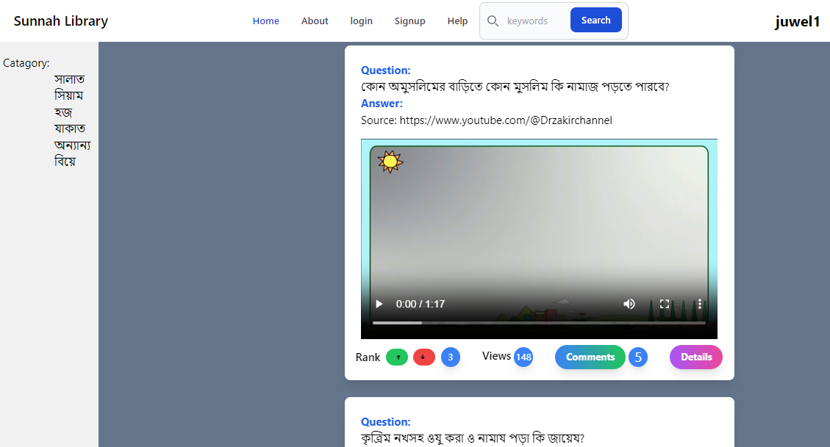3.2.1 Book Library Module Interface: The Book Library Interface focuses on the front-end implementation of the Book Library module in the "Learn Sunnah" website. This section covers the design and functionality of the book listing, search, and book details pages, providing users with access to a comprehensive collection of Sunnah-related resources.

# Figure 3.1: Learn Sunnah home page

1. **Book Listing Page**:

- Presents an organized display of Sunnah-related books.

- Categorized layout for easy navigation and content discovery.

- Grid-based view with book covers, titles, and brief descriptions for quick scanning.

# 

**2. Search Functionality:**

- Allows users to search for books based on keywords or topics.

- Utilizes an intelligent search algorithm for relevant results.

- Provides real-time suggestions for faster book discovery.

# Figure 3.2: Sunnah Library home page

**3. Book Details Page:**

- Displays in-depth information about each book, including the author and publication date.

- Offers direct access to the full book content in PDF format.

- Enables social sharing and interactive features such as rating and reviewing books.

# Figure 3.3: Book details page

3.2.2 Question & Answer Module Interface: The Question & Answer Interaction topic focuses on the frontend design and user interaction within the Question & Answer module of the "Learn Sunnah" website. This section aims to create an engaging and user-friendly platform that facilitates knowledge sharing and community discussions through the following features:

**1. User Interface for Posting Questions**:

- The frontend design includes a user-friendly interface for users to post their questions on various Sunnah-related topics.

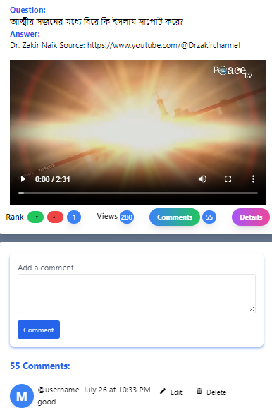 - Users can easily input their questions, add relevant details, and select appropriate categories for better organization.

**2. Viewing Answers**

- The frontend layout provides a clear and intuitive view of the answers to posted questions.

**3. Voting on Content:**

- Interactive voting elements allow users to express their opinions on the quality and relevance of answers and discussions.

- Upvoting and downvoting options contribute to a user-driven ranking system that highlights valuable content.

**4. Commenting and Engaging**:

- The frontend design facilitates

# Figure 3.4: Question view with comments

interactions through commenting on questions and answers.

- Users can engage in meaningful discussions, share insights, and seek clarifications, fostering a dynamic learning community.

The Question & Answer Interaction aims to create an interactive and collaborative platform that fosters knowledge sharing encourages community engagement, and enriches the overall learning experience of users seeking Sunnah-related guidance and information.

## 3.3 User Interaction and Navigation

The User Profile and Dashboard topic focuses on the frontend design of user-profiles and the personalized dashboard in the "Learn Sunnah" website. This section aims to provide users with a central hub to track their progress, contributions, and engagement on the platform through the following features

**1. User Profile:**

- The frontend design presents a comprehensive user profile page displaying essential user information such as name, profile picture, and bio.

- Users can view and manage their account settings, including email preferences and password changes.

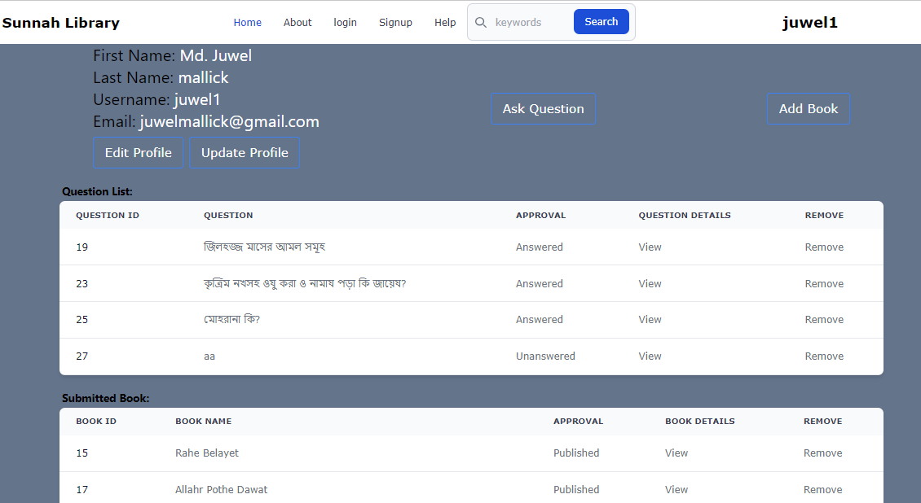 - The profile page also showcases user statistics, such as the number of questions posted, answers given, and contributions to the community.

# Figure 3.5: Profile with dashboard

**2. Personalized Dashboard:**

- The frontend dashboard offers a personalized overview of the user's activities and interactions within the platform.

- Users can access a summary of their submitted questions, answers received, and votes received on their contributions.

- The dashboard may include progress tracking features, showing achievements and milestones attained during the user's learning journey.

The User Profile and Dashboard aim to enhance the user experience by providing a personalized and informative interface, allowing users to track their learning progress, contributions, and community engagement effectively. It fosters a sense of ownership and motivation, creating a vibrant and interactive learning environment within the "Learn Sunnah" website.

## 3.4 Interactive Elements

**Content Submission Forms**

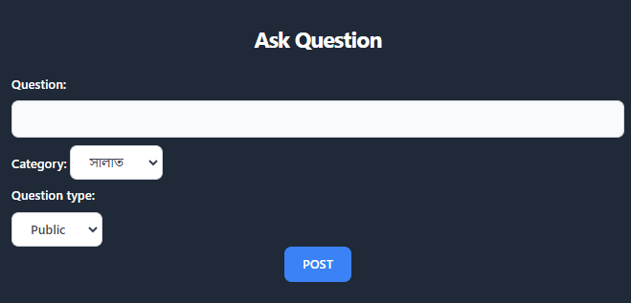- Description: Discusses the frontend implementation of content submission forms for questions and user-contributed content. This includes designing user-friendly forms with validation and feedback to ensure a smooth submission process.

**Interactive Components**

- Description: Explores the frontend development of interactive components, such as dropdowns, sliders, accordions, and tooltips. These components enhance user engagement and provide a seamless browsing experience.

# Figure 3.6: Question post form

## 3.5 User Experience and Optimization

**Visual Feedback**: Details the frontend display of visual feedback to inform users of successful actions, errors, or important updates. This includes displaying messages, alerts, and notifications in a user-friendly and unobtrusive manner.

By focusing on these frontend features, the "Learn Sunnah" website aims to provide a visually appealing, responsive, and accessible user interface that enriches the overall learning experience for its users.

**Chapter 4**

# Backend Features

## 4.1 Data Management and Database Design

This topic covers the backend aspects of data management and database design for the "Learn Sunnah" website. It involves designing and implementing the database structure to store user information, Sunnah-related resources, questions, answers, and other essential data. Additionally, it includes managing data operations such as data retrieval, insertion, updating, and deletion, ensuring data integrity, and optimizing database performance.

## 4.2 User Authentication and Authorization

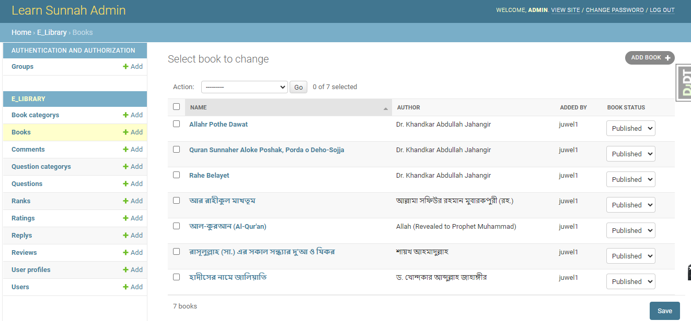This topic focuses on implementing user authentication and authorization mechanisms on the backend of the "Learn Sunnah" website. It includes features such as user registration, login, and password management. User authentication ensures that only registered users can access certain features, while authorization controls user permissions and access levels based on their roles, such as general users, moderators, and administrators.

# Figure 4.1: Django Admin panel

# 

## 4.3 Content Management System (CMS)

The CMS topic focuses on the backend development of a user-friendly system for moderators and administrators to manage and update content on the "Learn Sunnah" website. It includes:

**1. User-Friendly Interface**: An intuitive dashboard with clear menu options.

**2. Content Creation and Editing**: Creating and editing Sunnah-related resources, questions, and answers.

**3. Resource Organization**: Categorization and tagging for easy content organization.

**4. Content Approval Workflow**: Review process before publishing.

**5. Media Management**: Uploading, editing, and embedding multimedia content.

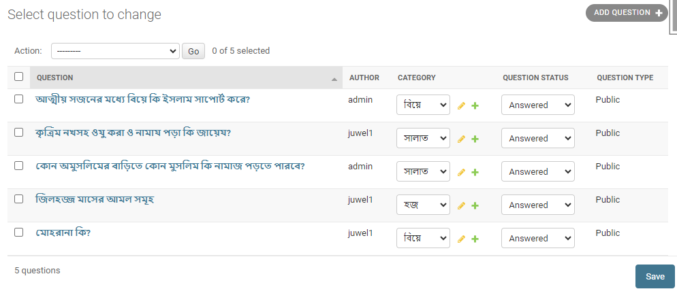**6. Access Control**: Ensuring authorized access for specific actions.

# Figure 4.2: Question manage in the backend

## 4.4 Backend API Development, Integration, and Error Handling

This topic encompasses the development of backend APIs (Application Programming Interfaces) for the "Learn Sunnah" website. APIs facilitate communication between the frontend and backend systems, allowing data exchange and integration with external services. It also includes handling API errors gracefully to provide meaningful feedback to users and developers when issues arise during data transmission or processing.

**Chapter 5**

# Project Evaluation and Future Plans

## 5.1 Performance Evaluation and User Feedback

Description: This topic involves evaluating the performance of the "Learn Sunnah" website from both technical and user experience perspectives. It includes analyzing website speed, responsiveness, and overall system performance. User feedback is collected and analyzed to gain insights into user satisfaction, identify areas of improvement, and address any issues or concerns raised by the user community.

## 5.2 Achievements and Challenges

* Assess project achievements and successes since implementation.
* Highlight reached milestones, accomplished goals, and positive impact on the target audience.
* Discuss challenges encountered during the project journey.
* Explore strategies to overcome or address these challenges.
* Evaluate user benefits, including access to diverse Sunnah resources in the free library.
* Examine community interaction and knowledge sharing facilitated by the platform.
* Recognize the role of expert guidance through the Q&A section.
* Discuss how the platform enables categorized search for specific topics, informative content updates, and implementation of Sunnah for a guided life.

## 5.3 Future Growth and Community Engagement

Description: This topic focuses on the future development of the "Learn Sunnah" website, encompassing enhancements, upgrades, expansion plans, and strategies for community engagement. It explores ways to improve the platform's features and functionalities, as well as methods to expand its reach and foster a vibrant and engaged user community.

* Implement bookmark functionality for users to save favorite resources.
* Provide live chat support moderated by staff for real-time assistance.
* Expand the collection of books and question & answer content.
* Add a notification bell for important updates and announcements.
* Explore new technologies and modern design elements for an enhanced user experience.
* Incorporate user-requested features based on feedback.
* Continuously improve functionalities and usability for a seamless learning experience.

## 5.4 Conclusion

The "Learn Sunnah" project has successfully created a user-friendly e-learning platform to facilitate the learning and implementation of Sunnah. With a comprehensive book library, an interactive Q&A section, and user profiles, the platform has empowered users to lead a more meaningful life based on the teachings of Sunnah. To address the identified limitations and implement future improvements, the project team remains committed to enhancing the platform's functionality and user experience. Through continuous efforts, "Learn Sunnah" aims to become a leading educational resource for Muslims worldwide.

**Reference**

Reference:

**https://www.wikipedia.org**

**https://islamqa.info/bn**

**https://www.youtube.com/@Drzakirchannel**